508 instructions for PDF

1. File>Properties>Advanced>Language> English
2. Advance>Accessibility>Full Check
3. Select Thumbnail of image>R-click>Page Properties>Use Document Structure
4. Advance>Accessibility>Touch Up Reading Order>Show Order Panel>Content Tab
   1. Find the image>R-click>Create Artifact
   2. Double Click on the image > tag as Figure
5. Document>Reduce File Size> 6.0 and Less

Convert image into text

Check if pdf is an image file, by performing a search

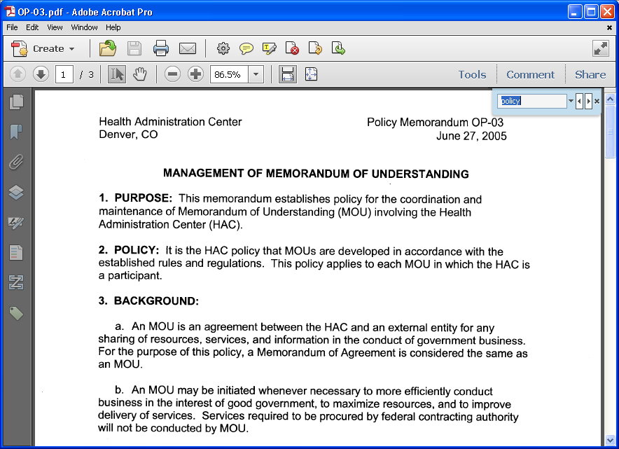

You will get the following return

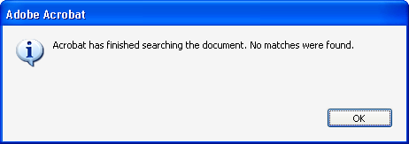

Click on the Tools icon

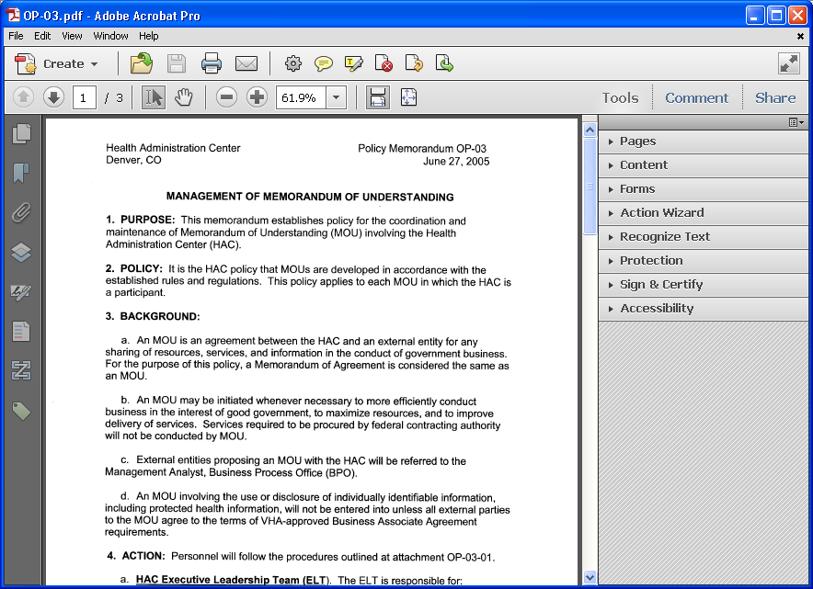

Expand the Recoginze Text then click “In This File”

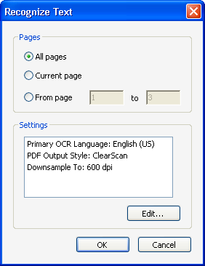

Click edit button

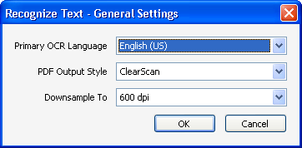

Be sure to use the above settings then click OK

Click on the Tag icon

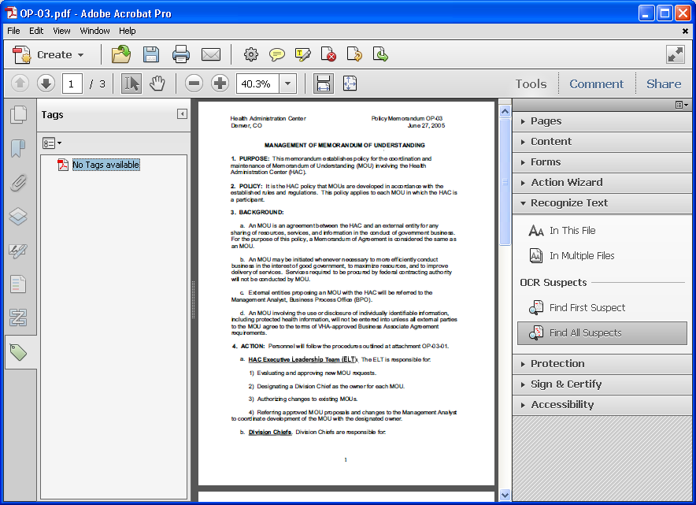

Right Click over “No Tags Available” then select Add Tags to Document

The program to will the appropriate files

Click on the Tag icon again

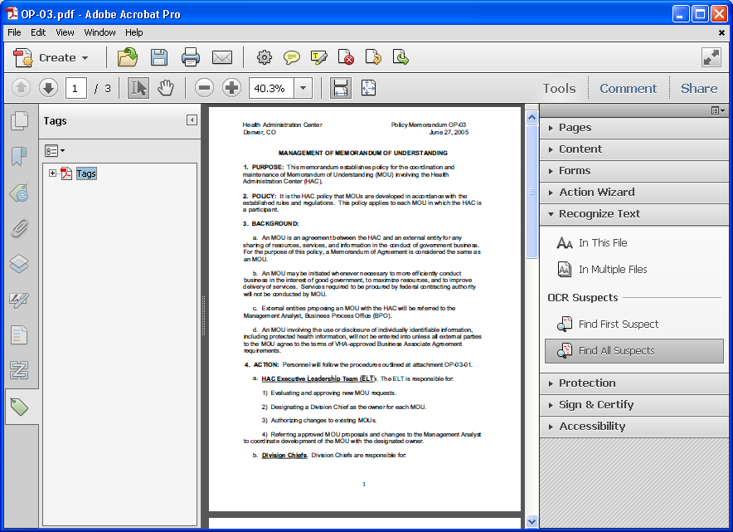

Expand Accessiblilty > Touch Reading Order

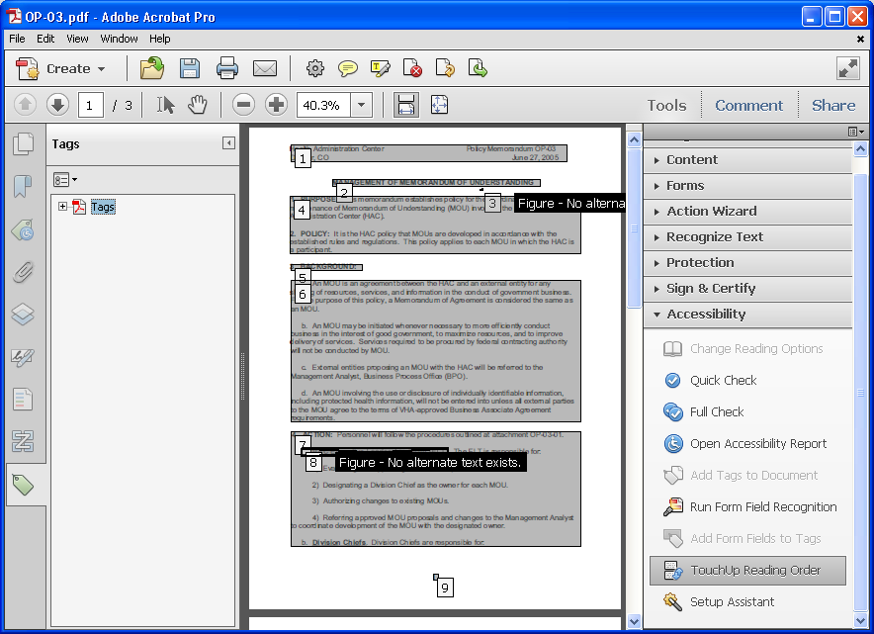

If you encounter “Figure – No alternative text exists” complete the following steps.

Click the Content Icon (3rd from the bottom left) and close the Tools menu

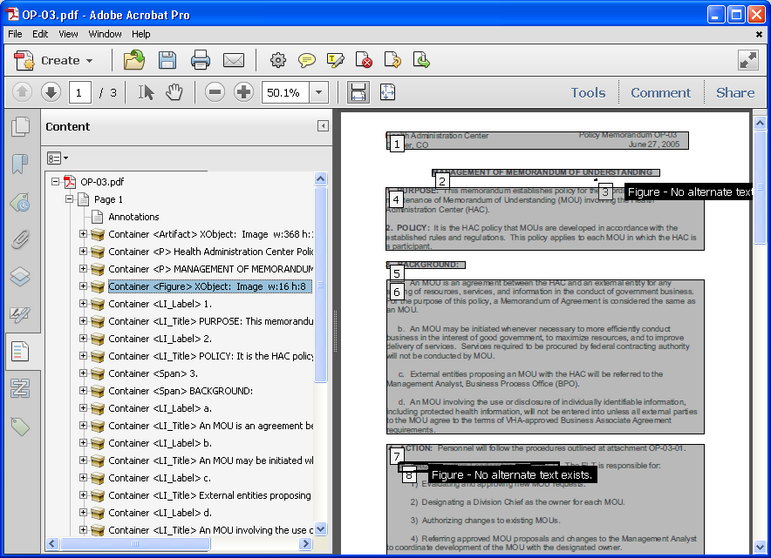

Highlight the Figure Containers

Right Click over the Container <Figure> XObject: Image > Highlight Content (to reveal what element you’re working with)

Right Click over the Container <Figure> XObject: Image > Create Artifact

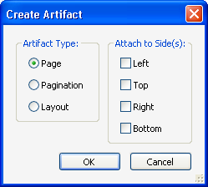

Select OK

Find the next Figure

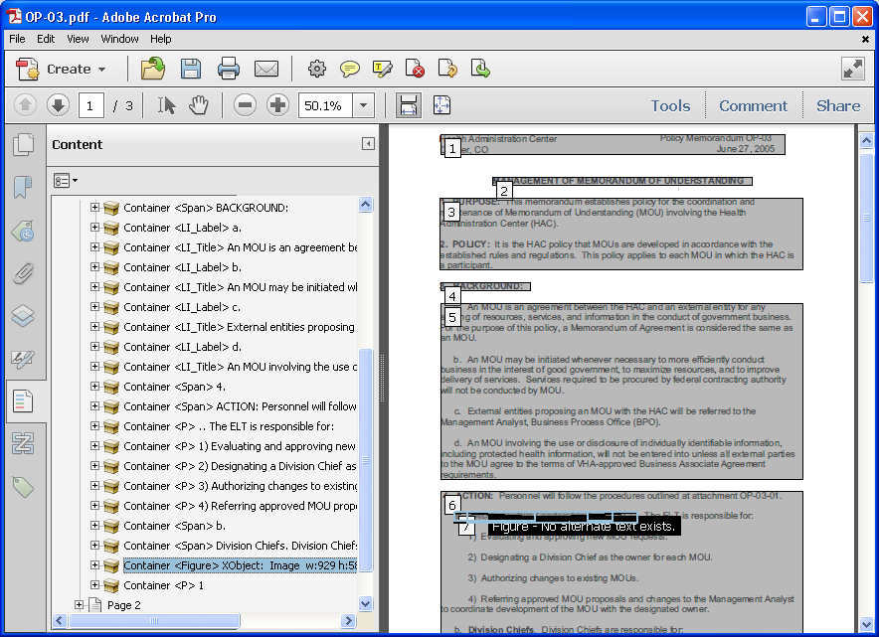

Repeat the process

Assign a language to the document.

File>Properties

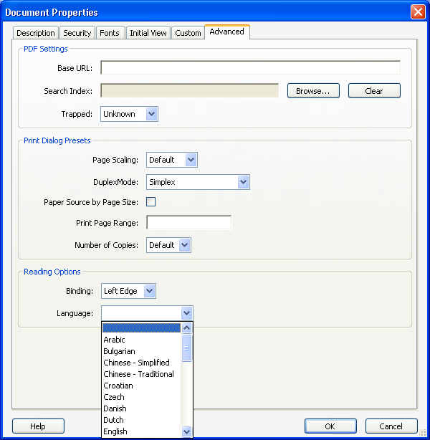

Select English then OK

Now perform a Full Accessibility check

Click on Tools Menu and expand the Accessibility>Full Check

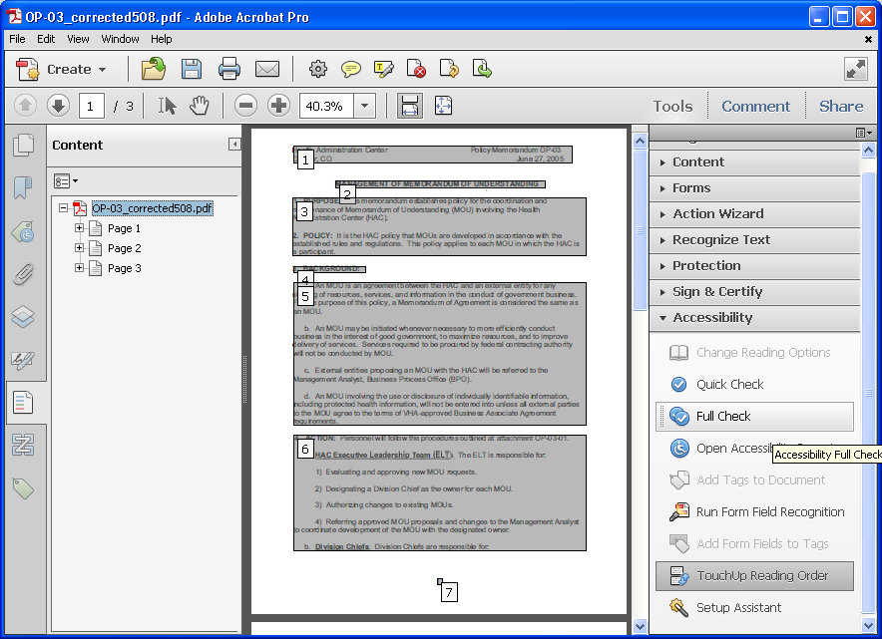

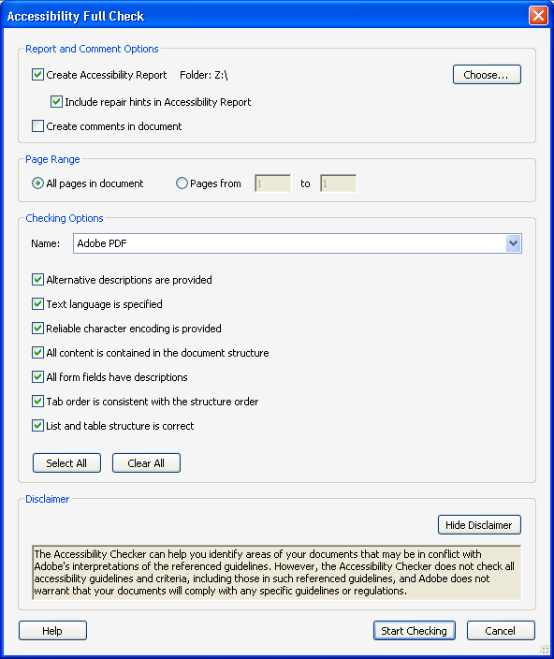

Be sure the above boxes are checked then click Start Checking

If you are success you will get a no problem response

To retag a Table to regular Text

Click on the Order Panel Icon (2nd from bottom left)

Find the Table

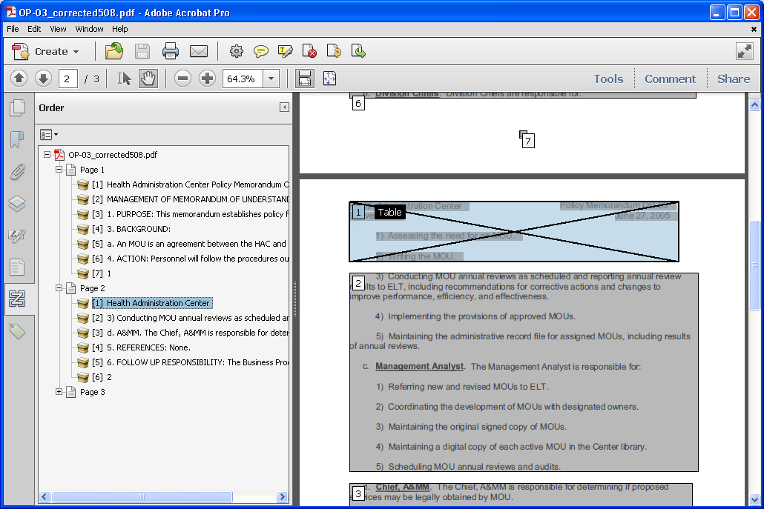

Right click over [1] Health Administration Center>select “Tag as Text”

